Design (pictures + paragraphs)

Objective:

Design a lamp diffuser to be laser cut out of a 3 mm sheet of balsa wood. Account for kerf and clearance such that it can support a press fit connection between members. We would like to diffuse light traveling upwards from the base and diffuse subtly outwards. The base that holds the light source will be 3d printed so this writeup will primarily focus on the shade itself. The assignment outlines a requirement of 3 unique laser cut parts with a minimum of 8 total pieces.

Once we have our part designed with easy to edit parameters we need to test for clearance and kerf values derived from material thickness measurements and two test cuts (one for kerf and one for press fit tolerances). Following that we will update our CAD and run the full cut. If all of the previous work is done well, assembly should be quite simple and we will have a complete diffuser ready for use.

CAD:

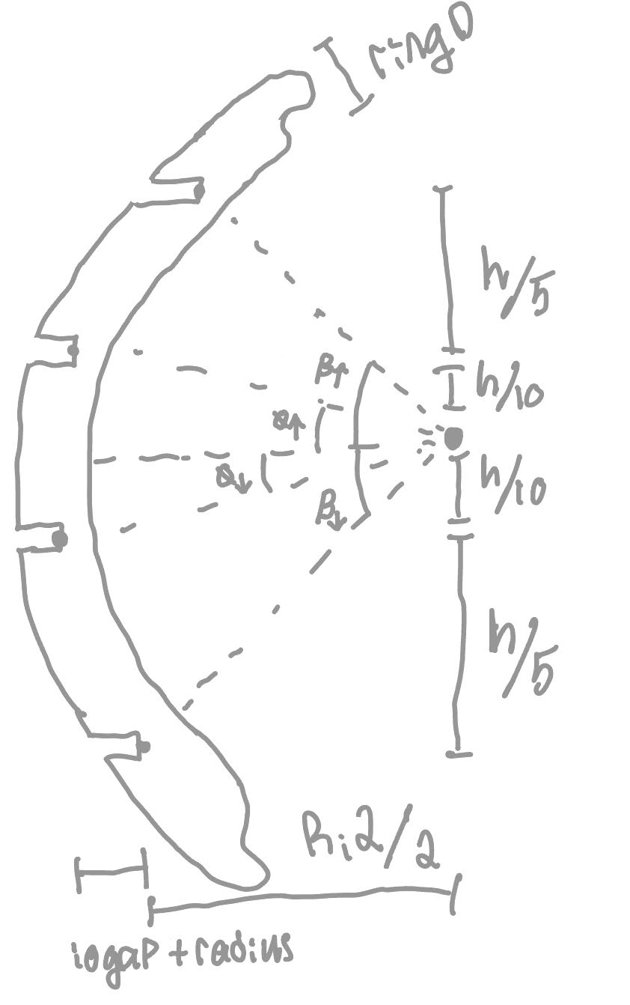
Test Drawing Getting Parameters
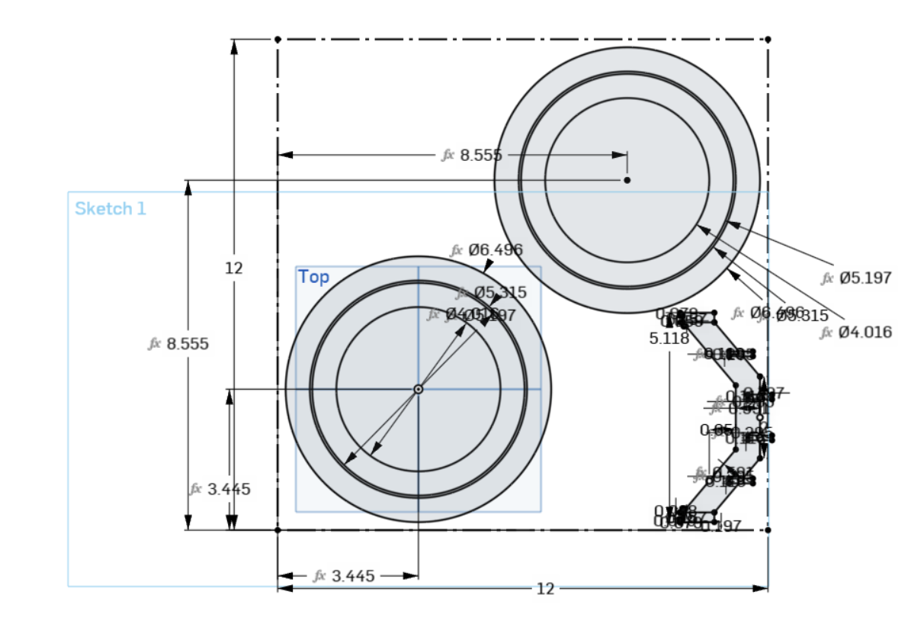
Test Sheet Sketch
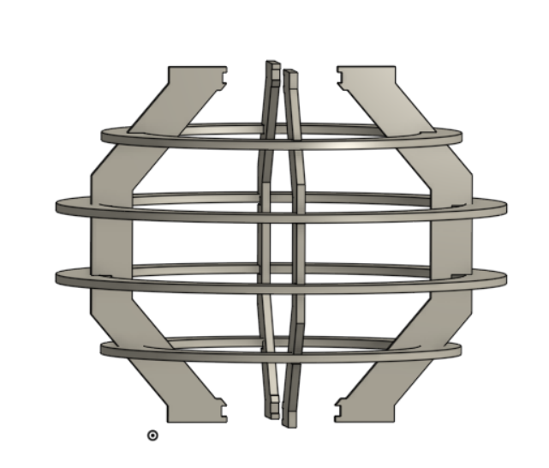
Test Assembly

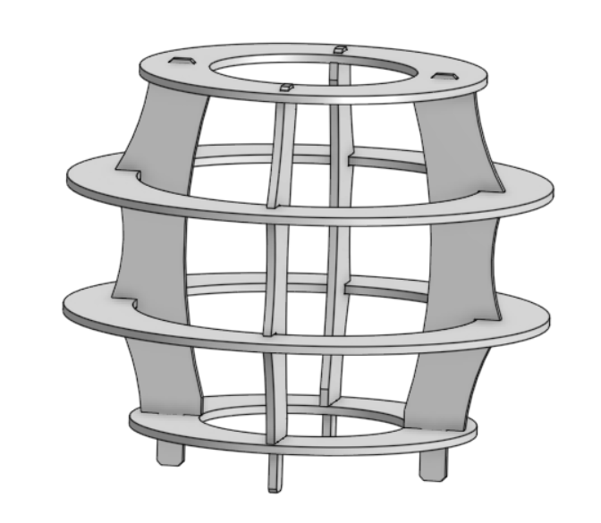
Final Assembly Laser Cut

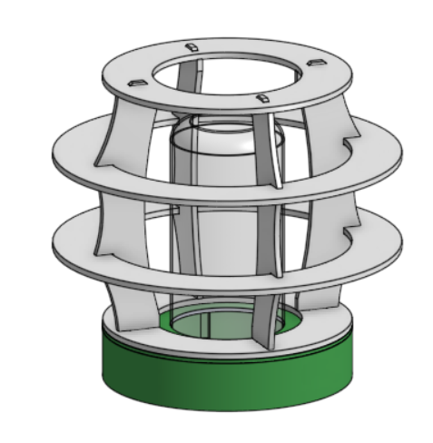
Final Assembly With Base

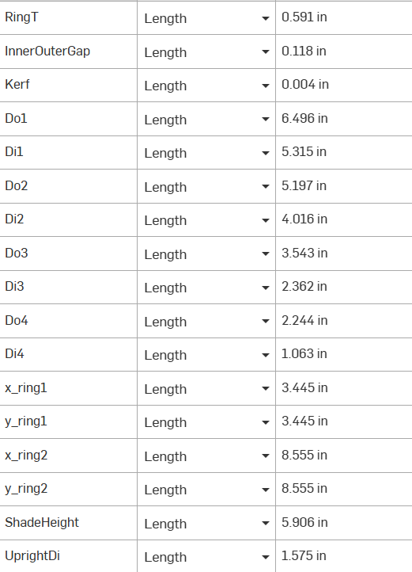
Test Variable Table

This project was conceptualized in OnShape with the final design work being done in SolidWorks. The conceptual work was mostly figuring out how all of the pieces would be constrained and ensuring all parts could fit on the material stock we were provided. The final design work was working through aesthetics, clearances, and kerf values. Both were designed parametrically. Clearance values were minimal, just accounting for the variance in stock thickness (+- .2 mm on a 3 mm sheet). Because the material we are using is fairly compliant, we were able to keep the fits tight. The small rings are attached with a press fit.

While trying to design the test piece, we wanted to make as many dimensions as possible reliant upon a small handful of parameters (the control factors) so a lot of sketches like the one shown above were used to define those. The final version used a very different upright geometry however it retained a lot of the same math that allowed for parametric design in the test part.

Manufacturing, including Process Research (pictures + paragraphs)

Laser Cutting Justification and Explanation:

Laser cutters work by focusing high energy lasers onto a part to essentially melt or burn away the material. This form of manufacturing requires blank material and large energy costs but is fast and relatively repeatable. For most materials, the laser provides so much concentrated power that the material as a whole stays cool while the spot the laser is focused on evaporates. Because focusing implies the ray comes together at a point then diverges again, the edge of a cut is ever so slightly tapered. This is far more apparent on a thicker blank but the height of the laser above the workpiece can also affect the angle of this taper.

The two most prevalent types of lasers on the market today are CO2 and fiber lasers. Fiber lasers are typically more expensive than CO2 lasers as they are able to do all of the same things but are more efficient, capable, and reliable. A big part of this reliability comes from using a fiber cable rather than mirrors as well as the laser source having a much longer lifecycle. The wavelength differences also account for some of the differences in performance. Fiber lasers have a shorter wavelength than CO2. This is not an issue with organic materials and plastics but they struggle to cut metals. Metal is however able to absorb short wavelengths so for a process that is suitable for metallic part manufacturing, one would seek out a fiber unit. Lastly, fiber laser machines are able to focus on a much smaller point which in practice means far higher energy density with the same total input. More energy per unit of surface area means cuts are much faster and have tighter tolerances.

Comparing laser cutting machines to FDM printers and CNC routers, it becomes apparent that they excel in some use cases and fall on their faces in others. Firstly, laser cutters are strictly for 2d manufacturing with small exceptions for etching. They however are the only option out of the three that can make nearly perfectly perpendicular inside corners. Industrial laser machines are often a little bit more expensive than a 3-axis CNC router that could do the same job but their use case is a little bit more defined. A laser cutter has a much lower tooling cost once purchased however. Lasers will be the fastest way to make a 2d part in almost all cases, especially as parts get bigger.

Live Demo

Measured Kerf:

Final Clearance Value:

Variable demonstration: add a picture of kerf or other variable and what it changes in the design when updated.

Control Factors: Those chosen by us

Slot width of 3 mm (material thickness) plus clearance

Max ring diameter of 165 mm to fit two sets on 12 x 12 sheet

2D distance between inner and outer ring: 1.5 mm

Height of “shade” = 150 mm (laser cut parts only, excluding 3d printed base)

Ring diameters: Inner ring fits into outer ring to allow for four large circular parts within the 12 x 12 piece of material. The smaller ring is the inner diameter of the large one minus the kerf value.

Press fit Clearance:

Step 3: Run a fit test. Callback: Taguchi. This is a small parameter study, the same method you used for infill in Week 2.

- Design a fit coupon with one tab and 3 slots at 3 different clearances (tight, target, loose), based on your measured thickness and kerf.
- Cut and test it. Rate each fit and photograph the results.

Noise Factors: Things outside of our control

Thickness Measurement # | 1 | 2 | 3 | Mean
Value (mm) | 2.88 | 2.80 | 2.96 | 2.88

Kerf:
- Choose a square size, D, between 15 mm and 30 mm. Record the value you chose.
- Design and cut one D × D square kerf coupon.
- Measure the square with calipers in both the X and Y directions.
- Kerf = D − measured width. Record both values and note any difference between X and Y.

Measurement # | 1 | 2 | 3 | mean
X dimension | .11 mm | .1 mm | .12 mm | .11 mm
Y dimension | .17 mm | .21 mm | .19 mm | .19 mm

Kerf Variation: Accounted for with clearance and softness of material as its such a small value

Focus: error added through this is accounted for through kerf and clearance. It is quite hard to get a defined value for the error here as it changes based upon variation in the wood thickness as well as the flatness of the workspace.

Notes on cut edges (soot, finish, etc): The material was thin enough that we couldn’t see the taper from the laser focusing. They had some soot on the edge but it was super minimal.

Laser Process Record

Setting
Laser cutter (name or number) | LA 3
Material type | Balsa Wood
Nominal thickness | 3 mm
Measured thickness (mean) | 2.7
Speed | 20%
Power | 100%
Frequency or PPI (if applicable) | 25%
Number of passes | 1
Focus method and how you confirmed it | Standard focus, confirmed with the lab tech
Air assist on? Exhaust on? | Yes and yes!
How you set origin and alignment | Used the upper left corner for both sketch and material alignment

Cutting

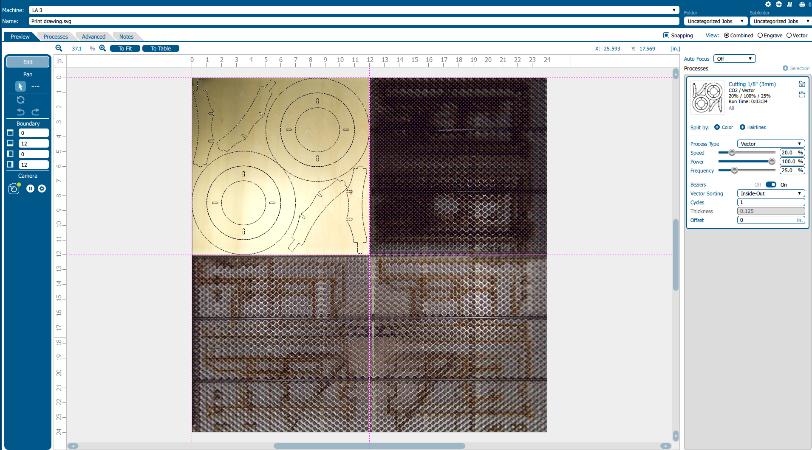
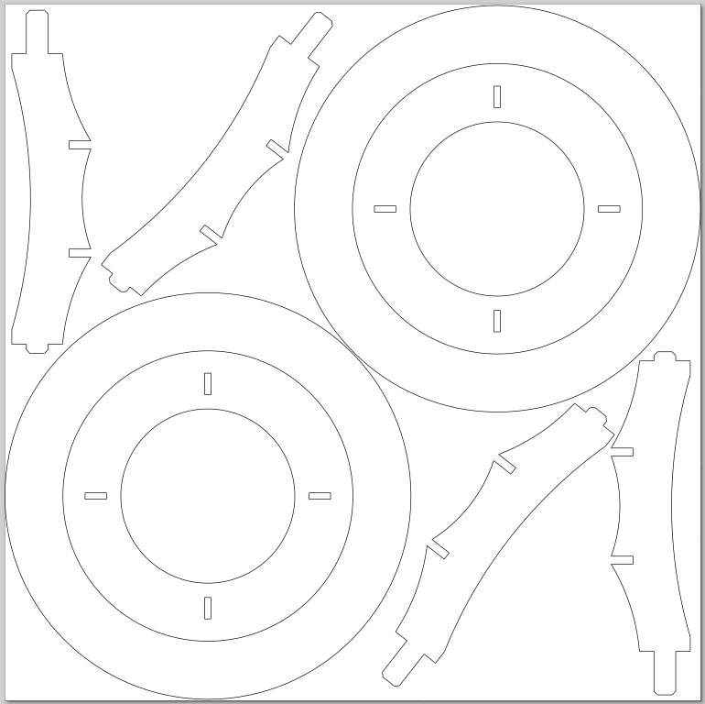
Drawing of Cut Path on 12” x 12” sheet

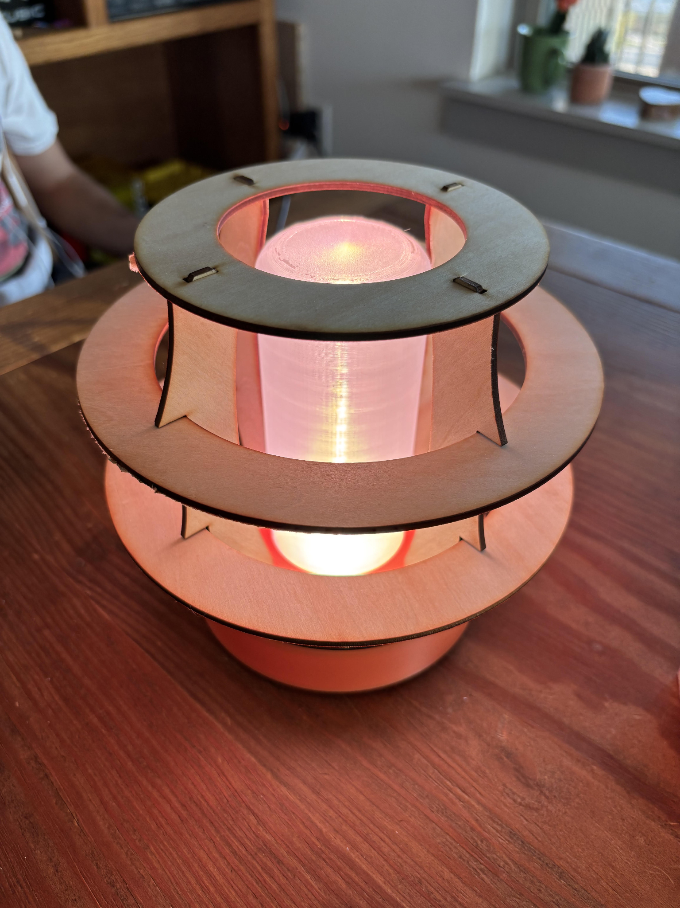
Final Product
Lessons Learned (pictures + paragraphs)

Include your completed Process Log, with total time from start to finish.

Describe your mistakes, troubleshooting, and what you changed. Use photos.

List resources used: material size and type, number of sheets, any consumables, and tools for assembly and cleanup.

Answer these reflection prompts:
- Where did your measured values differ from what you assumed (nominal thickness, expected kerf)? What would have happened if you had used the assumed value?
- Using Taguchi's quality loss function, describe one joint in your kit that works but is not on target. What would that loss mean if the part were made by the thousands?
- Name a real product that uses cut sheet parts joined by tabs and slots (for example, flat pack furniture or sheet metal enclosures). How would a kerf or thickness error show up for the customer?
- If you had one more cut, what would you change, and why?

